**Quiz 1**

Question 1: *Choose the best answer:*

1. Computer vision defined as a discipline in which …………………..
   1. The input of a process is an image description and the output is image
   2. Both the input and output of a process are descriptions.
   3. The input of a process is an image and the output is an image description.
   4. Both the input and output of a process are images.
2. One of the following functions is not an IPT (image processing toolbox) function used to convert images.
   1. dither () c. rgb2gray ()
   2. gray2rgb () d. ind2gray ()
3. To map a narrow range of low gray-level input image into a wider range of output levels, we use
   1. Log Intensity Transformation Function
   2. Negative Intensity Transformation Function
   3. Inverse Log Intensity Transformation Function
   4. Identity Intensity Transformation Function
4. In ………………. image we notice that the components of histogram are concentrated on the low side on intensity scale.  
   a) bright b) dark  
   c) colourful d) All of the Mentioned
5. The ………………… of an image shows us the distribution of grey levels in the image.

a. histogram b. histogram equalization

c. contrast Stretching d. transformation function

6. ……………………….. bring out detail that is obscured, or simply to highlight certain features of interest in an image.

a. Image Restoration b. Segmentation

c. Image Enhancement d. Object Recognition

7. In a MxN image, M is the no. of………………..

a. intensity levels b. colors

c. rows d. columns

8. Each element of the matrix is called

a. dots b. coordinate

c. pixels d. value

9. Imaging system produces

* + - 1. high resolution image c. voltage signal
      2. digitized image d. analog signal

10. Black and white images have only

a. 2 levels c. 3 levels

1. 4 levels d. 5 levels

11. Intensity levels in 8bit image are

a. 255 b. 256

c. 244 d. 245

12. Process that expands the range of intensity levels in image is called

a. linear stretching b. contrast stretching

c. color stretching d. elastic stretching

13. Histogram is the technique processed in

a. intensity domain b. frequency domain

c. spatial domain d. undefined domain

14. In power transformation values are dependent on value of

a. x-rays b. alpha

c. beta d. gamma

15. In the formula g(x,y) = T[ƒ(x,y)], T is the

a. transformed image

b. transformation vector

c. transformation theorem

d. transformation function

16. Gamma correction is mostly used in

a. CRT devices b. audio devices

c. radio d. turbines

17. In bit plane slicing the most of the information of an image is contained by

a. highest order plane b. lowest order plane

c. mid order plane d. all planes

18. Thresholding function in contrast stretching creates

a. binary image b. high quality image

c. enhanced image d. low quality image

19. Sum of all components in normalized histogram is equal to

a. 100 b. 2

c. 0 d. 1

20.  Strictly monotonical function guarantee the inverse mapping as

a. dual valued b. single valued

c. multi valued d. running sum

21. The greyscale clipping function in the right is applied on an image having the histogram in Fig. a). Then, most likely, the histogram of the processed image will look:

a) like in Fig.b); ­­ b) like in Fig.c); c) like in Fig.d); d) the same as before processing, since we have a linearfunction.

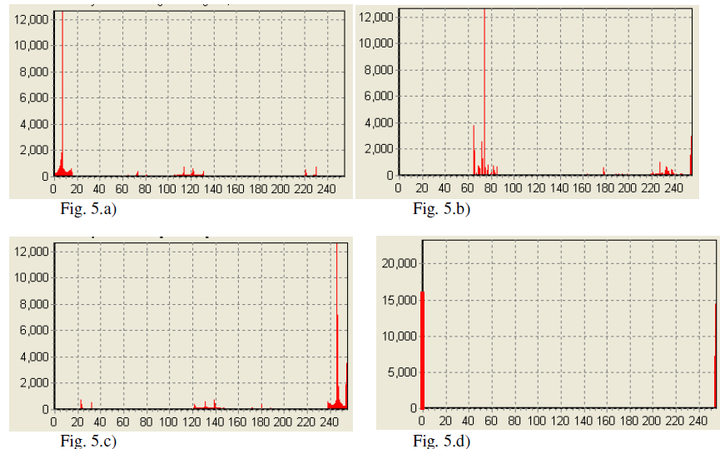

# Question 2:

Consider the image shown below; compute the equalized image with eight possible gray levels. Show each step carefully. Draw the histograms of the original and equalized images as well as the equalization transformation.

|  |  |  |  |  |  |
| --- | --- | --- | --- | --- | --- |
| 1 | 2 | 1 | 1 | 2 | 0 |
| 0 | 1 | 5 | 1 | 0 | 1 |
| 1 | 6 | 7 | 6 | 1 | 2 |